## Custom Pipes

**Learning Objectives**

* Know how to use the @Pipe decorator to create pipes.
* Know how to pass in parameters to custom pipes.

**Pipe decorator**

One pipe I really find useful when building web applications is a *default* pipe, which I use for things like avatar images.

I use this pipe in an image field, like so:

<

img [src]="imageUrl | default:'<default-image-url>'"/

>

The pipe is called default and we pass to it a default image to use if the imageUrl variable is blank.

To create a pipe we use the @Pipe decorator and annotate a class like so:

import { Pipe } from '@angular/core';

.

.

.

@Pipe({

name:"default"

})

class DefaultPipe { }

The name parameter for the Pipe decorator is how the pipe will be called in templates.

**Transform function**

The actual logic for the pipe is put in a function called transform on the class, like so:

class DefaultPipe {

transform(value: string, fallback: string): string {

let image = "";

if (value) {

image = value;

} else {

image = fallback;

}

return image;

}

}

The first argument to the transform function is the *value* that is passed *into* the pipe, i.e. the thing that goes *before* the | in the expression.

The second parameter to the transform function is the first param we pass into our pipe, i.e. the thing that goes after the : in the expression.

Specifically with this example:

@Component({

selector: 'app',

template: `

<img [src]="imageUrl |

default:'http://s3.amazonaws.com/uifaces/faces/twitter/sillyleo/128.jpg'"/>

`

})

class AppComponent {

imageUrl: string = "";

}

* value gets passed imageUrl which is blank.
* fallback gets passed 'http://s3.amazonaws.com/uifaces/faces/twitter/sillyleo/128.jpg'

When we run the above, since imageUrl is blank the default pipe uses the default image which is passed in, like so:

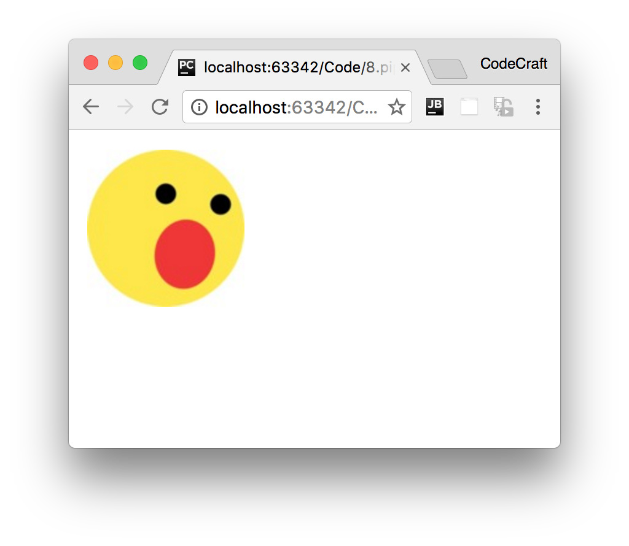

**Multiple parameters**

Finally we want to support an *optional* third param to our pipe called forceHttps, if the image selected doesn’t use *https* the pipe will convert the url to one that does use *https*.

To support additional parameters in pipes we just add more parameters to our *transform* function.

Because this one is optional and we are using TypeScript we can define the new param and also give it a default value of false.

class DefaultPipe {

transform(value: string, fallback: string, forceHttps: boolean = false): string {

let image = "";

if (value) {

image = value;

} else {

image = fallback;

}

if (forceHttps) {

if (image.indexOf("https") == -1) {

image = image.replace("http", "https");

}

}

return image;

}

}

And to use this optional param we just extend the pipe syntax in our template with another :, like so:-

<img [src]="imageUrl | default:'http://s3.amazonaws.com/uifaces/faces/twitter/sillyleo/128.jpg':true"/> ①

① Notice the last :true at the end of the pipe expression.

Now we force the image url to use the https protocol.

**Summary**

Creating a pipe is very simple in Angular. We just decorate a class with the @Pipe decorator, provide a name and a transform function and we are done.

**Listing**

*script.ts*

import {NgModule, Component, Pipe} from '@angular/core'; import {BrowserModule} from '@angular/platform-browser';

import {platformBrowserDynamic} from '@angular/platform-browser-dynamic'; import {Observable} from 'rxjs/Rx';

@Pipe({

name: "default"

})

class DefaultPipe {

transform(value: string, fallback: string, forceHttps: boolean = false): string {

let image = "";

if (value) {

image = value;

} else {

image = fallback;

}

if (forceHttps) {

if (image.indexOf("https") == -1) {

image = image.replace("http", "https");

}

}

return image;

}

}

@Component({

selector: 'app',

template: `

<img [src]="imageUrl |

default:'http://s3.amazonaws.com/uifaces/faces/twitter/sillyleo/128.jpg':true"/>

`

})

class AppComponent {

imageUrl: string = "";

}

@NgModule({

imports: [BrowserModule],

declarations: [AppComponent,

DefaultPipe

],

bootstrap: [AppComponent],

})

class AppModule {

}

platformBrowserDynamic().bootstrapModule(AppModule);

## Wrapping Up

Pipes are a way of having a different *visual representation* for the same piece of data without storing unnecessary intermediate data on the component.

We could solve the same problems without using pipes. We can transform the data ourselves on the component into different property, in all the different permutations they are required in all the views they are consumed in.

But that’s wasteful and a fertile feeding ground for bugs.

Instead we use pipes which are used in templates and transform the data passed to it on demand in the format the consumer of the data wants without needing to store any intermediate values on our component.

## Activity

Create a custom *Pipe* called CleanPipe for use in the Joke application which replaces instances of a *bad* word with $%#@! instead.

We want to pass into the pipe the list of bad words which we want replace, like so:

<

p>{{data.punchline | clean:'boo,damn,hell'}}</p

>

**Steps**

Fork this plunker: <http://plnkr.co/edit/nlRZRJnB8jEScijgZ9J6?p=preview>Flesh out the CleanPipe class to implement the functionality.

Read any **TODO** comments in the plunker for hints.

**Solution**

When you are ready compare your answer to the solution in this plunker:

<http://plnkr.co/edit/CWPCpzzIjkPdYet6prLj?p=preview>